Purdue Global University
HW320 Contemporary Diet and Nutrition
Nutrition Education Guide

purdue global University

Nutrition Education Guide
By

Clifford Cornell Hughley

Purdue Global University
HW320: Contemporary Diet and Nutrition

18 July 2023

Table of Contents

Introduction
Unit 1 Dietary Trends and Nutrition
Information to Remember
Resource
Unit 2 Food Choices
Information to Remember
Resource
ResourceUnit 3 Food ChoiceS: Economics
Information to Remember
Resource
ResourceUnit 4 Food ChoiceS: fOODBORNE iLLNESSES
Information to Remember
Resource
ResourceUnit 5 gENETICALLY eNGINEERED fOOD
Information to Remember
Resource
ResourceUnit 6 tHE oRGANIC fOOD moVEMENT
Information to Remember
Resource
ResourceUnit 7 gLOBAL fOOD mARKETS
Information to Remember
Resource
ResourceUnit 8 cONTEMPORARY weIGHT lOSS pROGRAMS
Information to Remember
Resource
ResourceUnit 9 dIVERSITY OF fOOD chOICES
Information to Remember
Resource
Unit
1
Dietary Trends and Nutrition
Unit 1 - The major factors that changed the role of nutrition in American dietary trends.

Information to Remember:
Unit 1 - The major factors that changed the role of nutrition in American dietary trends: Understanding the significant factors that have influenced changes in American dietary trends is crucial for nutrition practitioners and consumers alike. This knowledge helps practitioners tailor their advice to meet evolving nutritional needs, considering factors like cultural shifts, technological advancements, and advertising influences. Consumers benefit by being informed about how these factors impact their food choices, enabling them to make healthier and more conscious decisions for their well-being.

Resource:
- The resource "US evidence-based dietary guidelines: The history and the process" provides a comprehensive overview of the development of dietary guidelines in the United States, explaining the historical context and the rigorous process of creating evidence-based recommendations. This knowledge is vital for consumers and practitioners to understand the scientific basis behind dietary guidelines and the rationale behind specific nutritional advice. Consumers can make informed diet decisions by being aware of the process and the supporting evidence. At the same time, practitioners can confidently provide evidence-based nutrition advice to promote better health outcomes.
- Rome, S. (2014). US evidence-based dietary guidelines: The history and the process. Authentication required.https://eds-s-ebscohost.com.libauth.purdueglobal.edu/eds/pdfviewer/pdfviewer?vid=1&sid=ce281c37-f3e5-4b5b-9e07-ecab8ed7ec52%40redis
Unit
2
Dietary Trends and Nutrition

Unit 2 - The factors that determine food choices.

Unit 2 - The factors that determine food choices: Understanding the factors influencing food choices is essential for practitioners and consumers. Practitioners can use this knowledge to design personalized dietary plans that align with individual preferences, socioeconomic status, and psychological factors. Consumers can make informed decisions by recognizing how taste, cost, convenience, and cultural upbringing affect their food choices, leading to healthier and more balanced diets.

Resource:
- This research highlights the factors influencing food choices among African Americans, focusing on a culturally sensitive model. The study addresses socio-cultural, environmental, and psychological determinants that impact this population's dietary intake and nutrition-related attitudes. Practitioners can benefit from this resource by tailoring their advice to align with the cultural and environmental factors influencing their African American clients' food choices. Consumers can also gain valuable insights into understanding their dietary behaviors and adopting healthier eating habits within their cultural context.
- Odoms-Young, A. M., Whitt-Glover, M. C., & McGuire, L. A. (2012). Factors Influencing Food Choices, Dietary Intake, and Nutrition-related Attitudes among African Americans: Application of a Culturally Sensitive Model. Ethnicity & Disease, 22(2), 209-215. Retrieved from https://pubmed.ncbi.nlm.nih.gov/22870573/

Unit
3
Dietary Trends and Nutrition

Unit 3 - Economic Factors that impact family food needs

Information to Remember:

Unit 3 - Economic factors that impact family food needs: Practitioners and consumers must grasp the economic factors influencing family food needs to promote better food security and financial well-being. Understanding the impact of income, inflation, and access to affordable, nutritious food helps practitioners provide relevant advice to families facing financial constraints. Consumers can make budget-conscious choices while ensuring their families receive adequate nutrition.

Resource:
- The resource "Impacts of the 2008 Great Recession on dietary intake: a systematic review and meta-analysis" presents a thorough analysis of the effects of the 2008 economic recession on dietary intake patterns. This systematic review and meta-analysis provide valuable insights for consumers and practitioners, shedding light on how economic downturns influence food choices and nutritional behaviors. By understanding the potential impacts of financial crises on dietary intake, consumers can be more conscious of their food choices during challenging economic times, while practitioners can offer tailored advice to help individuals and families maintain adequate nutrition despite financial constraints.
- Jenkins, R. H., Vamos, E. P., Taylor-Robinson, D., Millett, C., & Laverty, A. A. (2021, April 29). Impacts of the 2008 Great Recession on Dietary Intake: A systematic review and meta-analysis. The international journal of behavioral nutrition and physical activity. https://www.ncbi.nlm.nih.gov/pmc/articles/PMC8084260/

Unit
4
Dietary Trends and Nutrition

Unit 4 - Foodborne illness outbreaks in the U.S.

Information to Remember:

Unit 4 - Foodborne illness outbreaks in the U.S.: For practitioners, knowledge of foodborne illness outbreaks is crucial for identifying potential risks, implementing preventive measures, and managing cases effectively. This information helps protect public health and strengthen food safety protocols. Consumers benefit from understanding these outbreaks as they can take necessary precautions, such as handling food safely and being aware of product recalls, to avoid falling ill due to contaminated food.

Resource:
- The Centers for Disease Control and Prevention (CDC) report documents multistate foodborne illness outbreaks in the United States from 2010 to 2014. It provides valuable information for both practitioners and consumers to be aware of the risks associated with contaminated food. Practitioners can use this resource to stay updated on common pathogens causing outbreaks and their preventive strategies. At the same time, consumers can learn about recent attacks and take necessary precautions to protect themselves and their families from foodborne illnesses.
- Cortes, M. M., Williams, I., & Griffin, P. M. (2015). Multistate Foodborne Outbreaks - United States, 2010-2014. Morbidity and Mortality Weekly Report (MMWR), 64(24), 668-672. Retrieved from https://www.cdc.gov/mmwr/preview/mmwrhtml/mm6424a3.htm

Unit
5
Dietary Trends and Nutrition

Unit 5 - Benefits of agricultural biotechnology

Information to Remember:

Unit 5 - Benefits of agricultural biotechnology: Practitioners can benefit from understanding agricultural biotechnology's potential to enhance food production, improve nutritional content, and address environmental challenges. This knowledge allows them to guide consumers on the safety and benefits of genetically modified organisms (GMOs) in food. Consumers can make informed choices by weighing the advantages of increased food availability and potential nutritional improvements against concerns about GMO safety and environmental impact.

Resource:
- The resource "U.S. Department of Agriculture - Biotechnology Frequently Asked Questions (FAQs)" is an essential reference for consumers and practitioners to be aware of in contemporary nutrition practices. It comprehensively answers common questions about biotechnology in agriculture, addressing concerns, safety measures, and regulations. By accessing these FAQs, consumers can better understand the role of biotechnology in food production, helping them make informed decisions about their dietary choices. Practitioners can use this resource to stay updated on the latest information about agricultural biotechnology, enabling them to offer evidence-based guidance and recommendations to their clients regarding biotech-enhanced products and their potential impact on health and the environment.
- U.S. Department of Agriculture. (n.d.). Biotechnology: Frequently asked questions. http://www.usda.gov/wps/portal/usda/usdahome?contentidonly=true&navid=AGRICULTURE&contentid=BiotechnologyFAQs.xml
Unit
6
Dietary Trends and Nutrition

Unit 6 - What qualifies as organic food?

Information to Remember:

Unit 6 What qualifies as organic food?: For practitioners and consumers, knowing the criteria for organic food is vital for making informed decisions about its potential health and environmental benefits. Practitioners can educate clients about the benefits and limitations of organic food choices, while consumers can confidently choose organic products that align with their values and health preferences.

Resource:
- The resource "Organic Foods: Are They Safer? More Nutritious?" by the Mayo Clinic is essential for consumers and practitioners to be aware of in contemporary nutrition practices. This comprehensive article provides evidence-based insights into organic foods' safety and nutritional benefits compared to conventionally grown counterparts. It explores potential advantages, such as reduced pesticide exposure and higher nutrient levels, while highlighting the importance of overall dietary patterns. Awareness of the Mayo Clinic's research can help consumers make informed decisions about incorporating organic products into their diets. At the same time, practitioners can use the information to guide clients in making well-balanced choices aligned with their health goals.
- Mayo Clinic. (2020). Organic foods: Are they safer? More nutritious? https://www.mayoclinic.org/healthy-lifestyle/nutrition-and-healthy-eating/in-depth/organic-food/art-20043880

Unit
7
Dietary Trends and Nutrition
Unit 7 Dietary Trends and Nutrition

Information to Remember:

Unit 7 - The risks of fast-food globalization: Understanding the risks associated with fast-food globalization is essential for practitioners and consumers. Practitioners can use this knowledge to raise awareness about the potential health consequences of excessive fast-food consumption, including obesity and diet-related diseases. Consumers can make informed choices about their diets, balancing convenience with healthier options to mitigate the negative impacts of fast-food globalization on their well-being. Resource:
- The Resource "Fast Food Nation: The Dark Side of the All-American Meal - Chapter 10: Globalization" by Eric Schlosser sheds light on the impacts of fast food globalization, making it essential for consumers and practitioners in contemporary nutrition practices. This chapter explores how the expansion of fast-food chains worldwide has influenced global food systems, local diets, and public health. Consumers can gain awareness of the socio-economic and health implications of fast-food globalization, helping them make informed diet choices and advocating for more sustainable and healthier food options. Practitioners can use this information to address the challenges of fast food's global influence and promote nutrition strategies prioritizing health and cultural diversity.
- Eric Schlosser. (2001). Fast food nation : The dark side of the all-American Meal: Chapter 10: Globalization. Mariner Books.

Unit
8
Dietary Trends and Nutrition
Unit 8 Dietary Trends and Nutrition

Information to Remember:

Unit 8 - The risks of using drugs to lose weight: Practitioners must be aware of the risks associated with weight-loss drugs, as it helps them provide safe and effective weight management advice. Consumers benefit from understanding the potential side effects and limitations of weight-loss medications, enabling them to make more informed decisions about their weight-loss journey and overall health.

Resource:
- The resource "Prescription Medications to Treat Overweight and Obesity" by the National Institute of Diabetes and Digestive and Kidney Diseases is crucial for consumers and practitioners in contemporary nutrition practices. This resource provides valuable information on prescription medications for managing overweight and obesity, highlighting their potential benefits, risks, and side effects. Consumers can gain awareness of medical options to support weight management and understand the importance of informed discussions with healthcare providers. Practitioners can use this resource to stay updated on evidence-based pharmacological treatments, enabling them to provide comprehensive guidance to their patients and help them make informed decisions about weight management strategies.
- National Institute of Diabetes and Digestive and Kidney Diseases. (2021). Prescription medications to treat overweight and obesity. National Institutes of Health. https://www.niddk.nih.gov/health-information/weight-management/prescription-medications-treat-overweight-obesity

Unit
9
Dietary Trends and Nutrition
Unit 9 Dietary Trends and Nutrition

Information to Remember:

Unit 9 - The effects of ethnic and racial diversity on the nutritional needs of the population: Practitioners must consider the impact of ethnic and racial diversity on the nutritional needs of their clients to provide culturally appropriate and effective dietary advice. Understanding how genetics, cultural practices, and nutritional preferences vary among different populations allows practitioners to develop personalized plans that promote optimal health. Consumers also benefit from this knowledge as they can advocate for and access nutritional resources that reflect their unique backgrounds and requirements.

Resource:
- The resource "How Culture and Society Influence Eating" by Global Healing is essential for consumers and practitioners in contemporary nutrition practices. It delves into the powerful influence of culture and society on eating behaviors and food choices, offering insights into how cultural norms, traditions, and social environments shape our dietary habits. Consumers can better understand how their cultural background and societal norms impact their eating patterns, empowering them to make more conscious and health-conscious food choices. Practitioners can use this knowledge to provide culturally sensitive and personalized nutrition advice, recognizing the significance of cultural factors in their clients' dietary behaviors and promoting overall well-being.
- Group, E. (2016). How culture and society influence eating. https://explore.globalhealing.com/how-culture-and-society-influence-healthy-eating/.

Part 2: Cultural Food Choice Explanation and Screenshot
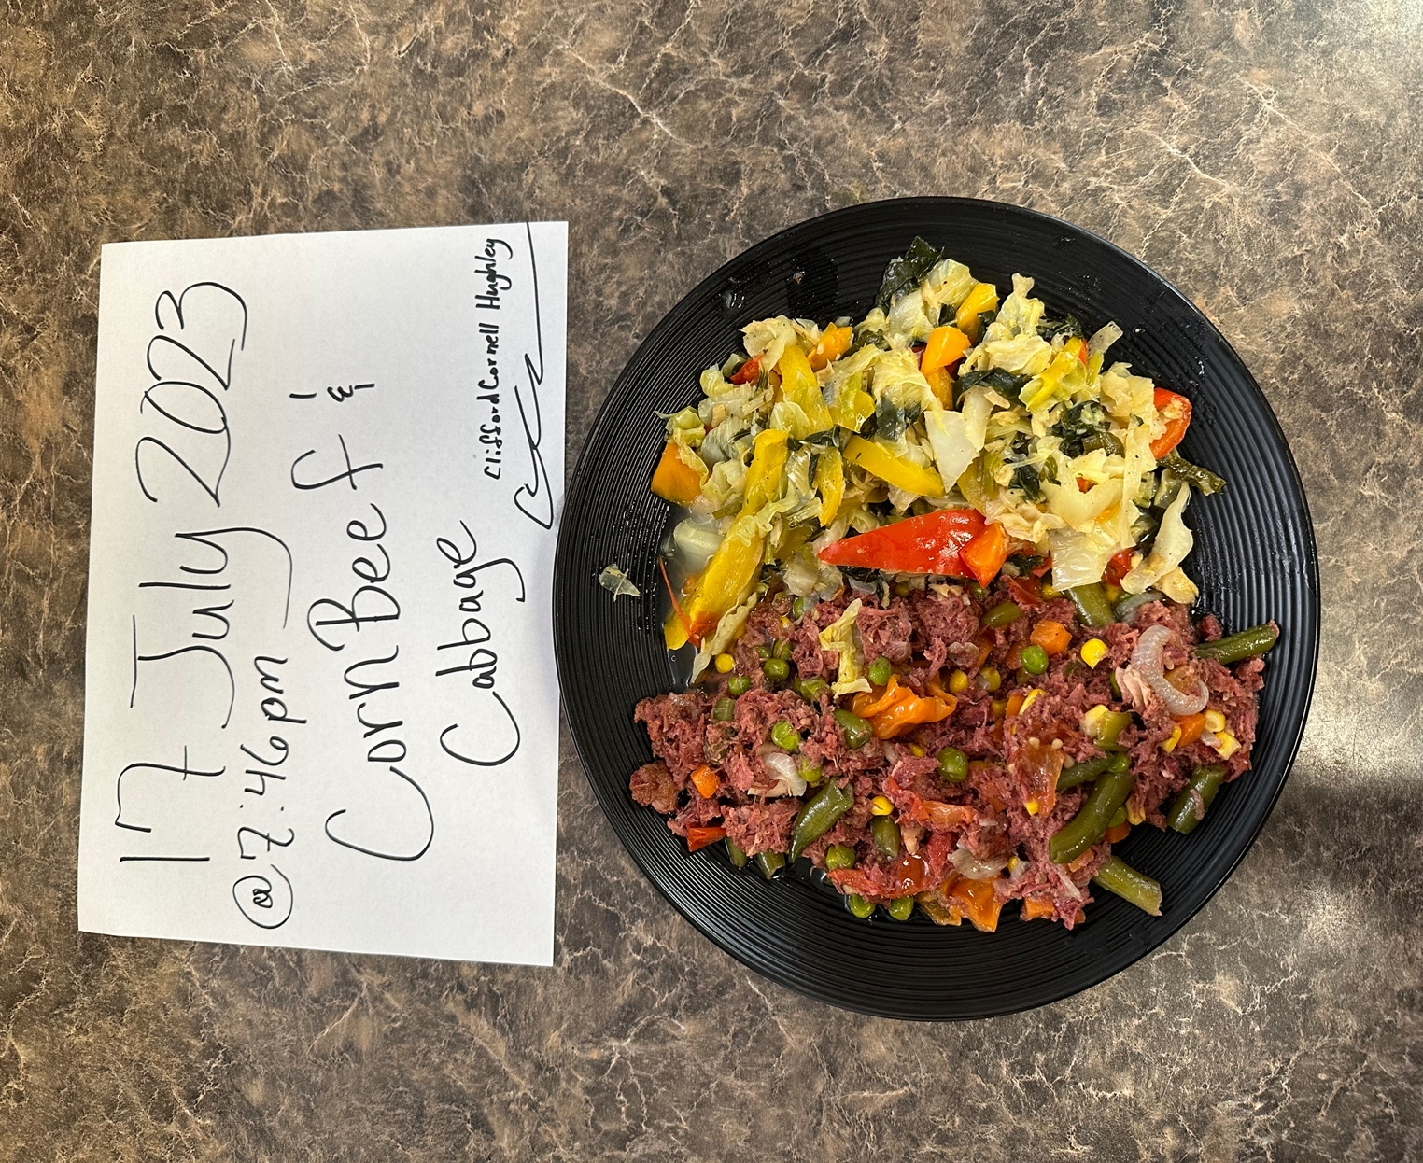

Jamaican food culture is a vibrant fusion of various influences, reflecting the island's history and diverse heritage. Key features that consumers and practitioners need to understand include traditional dishes, ingredients, culinary practices, and cultural significance.

One crucial aspect is using traditional ingredients like jerk seasoning, a spice blend consisting of Scotch bonnet peppers, allspice, thyme, and other spices, used to marinate and cook meats like jerk chicken and pork. Rice and peas, a staple side dish made with kidney beans and coconut milk, commonly accompanies many meals.

Jamaican cuisine is deeply tied to cultural celebrations and holidays. During Christmas, sorrel, a drink made from dried hibiscus flowers, is a traditional beverage, and fruitcakes soaked in rum are popular desserts. Festivals like Independence Day and Emancipation Day also feature traditional dishes and culinary competitions.

Furthermore, community and togetherness are essential in their "cookouts" or gatherings, where families and friends share meals, laughter, and music. Practitioners should recognize the significance of these social occasions, as they can impact dietary choices and overall well-being.

Understanding Jamaican food culture goes beyond recipes and ingredients; it involves recognizing its historical roots, influence from African, European, and Indian traditions, and the pride Jamaicans have in their culinary heritage. By appreciating these essential features, consumers and practitioners can foster cultural awareness, promote inclusive nutrition practices, and celebrate the richness of Jamaican food culture.

Overall, I had a fantastic experience preparing this dish. It was not difficult to make at all. The process begins with soaking the corned beef to remove excess salt, then gently simmering it in a pot with flavorful herbs and spices like thyme, allspice, and Scotch bonnet peppers. A tasty aroma fills the kitchen as the corned beef cooks, evoking memories of family gatherings and traditional Jamaican meals. I recommend anyone to make this recipe because I plan to make it again.

References:
Rome, S. (2014). US evidence-based dietary guidelines: The history and the process. Authentication required. https://eds-s-ebscohost-com.libauth.purdueglobal.edu/eds/pdfviewer/pdfviewer?vid=1&sid=ce281c37-f3e5-4b5b-9e07-ecab8ed7ec52%40redis
Odoms-Young, A. M., Whitt-Glover, M. C., & McGuire, L. A. (2012). Factors Influencing Food Choices, Dietary Intake, and Nutrition-related Attitudes among African Americans: Application of a Culturally Sensitive Model. Ethnicity & Disease, 22(2), 209-215. Retrieved from https://pubmed.ncbi.nlm.nih.gov/22870573/
Jenkins, R. H., Vamos, E. P., Taylor-Robinson, D., Millett, C., & Laverty, A. A. (2021, April 29). Impacts of the 2008 Great Recession on Dietary Intake: A systematic review and meta-analysis. The international journal of behavioral nutrition and physical activity. https://www.ncbi.nlm.nih.gov/pmc/articles/PMC8084260/
Cortes, M. M., Williams, I., & Griffin, P. M. (2015). Multistate Foodborne Outbreaks - United States, 2010-2014. Morbidity and Mortality Weekly Report (MMWR), 64(24), 668-672. Retrieved from https://www.cdc.gov/mmwr/preview/mmwrhtml/mm6424a3.htm
U.S. Department of Agriculture. (n.d.). Biotechnology: Frequently asked questions. http://www.usda.gov/wps/portal/usda/usdahome?contentidonly=true&navid=AGRICULTURE&contentid=BiotechnologyFAQs.xml
Mayo Clinic. (2020). Organic foods: Are they safer? More nutritious? https://www.mayoclinic.org/healthy-lifestyle/nutrition-and-healthy-eating/in-depth/organic-food/art-20043880
Eric Schlosser. (2001). Fast food nation : The dark side of the all-American Meal: Chapter 10: Globalization. Mariner Books.
National Institute of Diabetes and Digestive and Kidney Diseases. (2021). Prescription medications to treat overweight and obesity. National Institutes of Health. https://www.niddk.nih.gov/health-information/weight-management/prescription-medications-treat-overweight-obesity
Group, E. (2016). How culture and society influence eating. https://explore.globalhealing.com/how-culture-and-society-influence-healthy-eating/.

